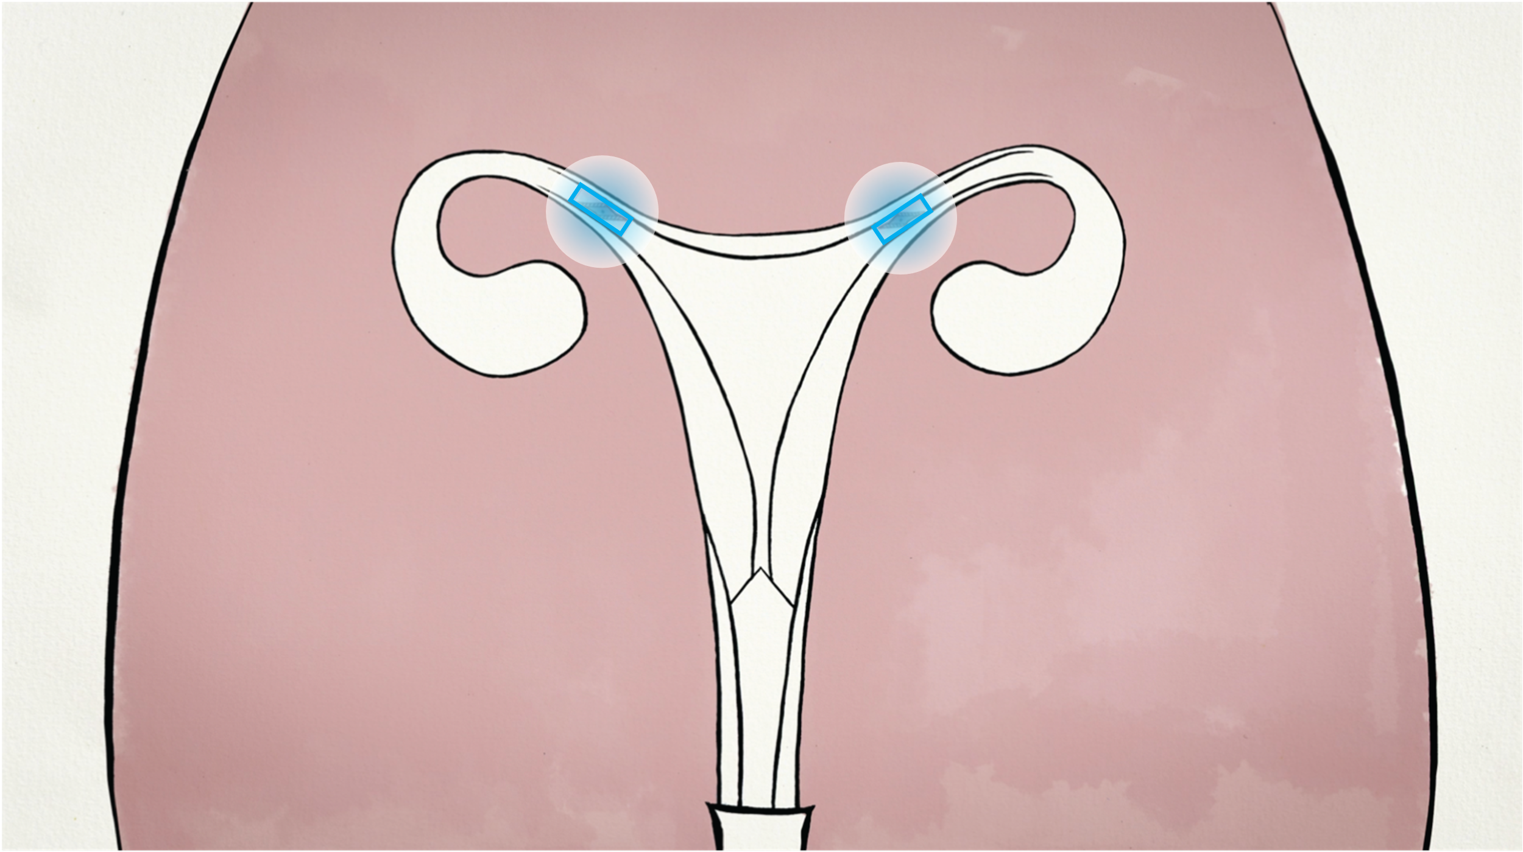

Breakthrough hormone-free lifetime
easy birth control

Investment Memorandum

Investment Memorandum (without NDA)

Choice B.V.
Office-S 4.004
Torenallee 20
5617BC Eindhoven
The Netherlands

http://www.choiceforwomen.org/

Peter van de Graaf , Msc. Founder & CEO
pvandegraaf@choiceforwomen.org
Tel: +(31) 65 325 0325

Place, date:
Eindhoven, May 2021

Status:
Published

DISCLAIMER
This document contains proprietary business information & is highly confidential.

The receipt of this plan constitutes the agreement on the part of the recipient to maintain the confidentiality of the information contained herein, as well as any supplemental information provided to the recipient by Choice B.V. or any of its representatives, either orally or in written form. Although management of Choice B.V. believes that the information contained herein is accurate as of the date of the writing of the document, Choice B.V. does not undertake to supplement or update it.

This document does not constitute & shall not constitute & shall not be construed as an offer to sell, or a solicitation of an offer to buy, any securities of Choice B.V.

Company summary

Company | Choice B.V.
Founded | 2014
Business | Development of a non-hormone based female friendly contraception method that enables managed population growth
Fiscal Year-End | December 31
Employees | 4
Locations | Eindhoven (Netherlands)
Revenues | Pre-revenue
Ownership | Fully diluted:  Founders (59,2%)  Partners (31,8%)  Stock Option Pool for essential advisors & staff (to be decided)
Financial Partners | Brabant Startup Fonds  Rabobank Innovatie Fonds
MedTech Partnerships | Technical University Eindhoven, The Netherlands  Utrecht University Medical Centre, The Netherlands  Maxima Medical Center, Veldhoven, The Netherlands  LifeTec group, Eindhoven, The Netherlands  Thales Paris, France  Catena Delft, The Netherlands  MeKo Hannover, Germany  Equipment & Prototyping Center, Eindhoven, The Netherlands
Societal Sponsors | Rutgers Stichting, Humanistisch Verbond
Banking Relationships | Rabobank
Auditors | Van Herwijnen Kreston, Tiel, The Netherlands
Lawyers | Stonewater , Amsterdam, The Netherlands
IP Lawyers | V.O. Patents & Trademarks, Eindhoven, The Netherlands
Funding Need | First-in-woman I 1,6M€, First-in-woman II 5M€, CE/FDA certification 3,3M€

Contents

EXECUTIVE SUMMARY 6
1. BUSINESS OVERVIEW 7
1.1 Choice’s History to Date 9
1.2 Which Problems does Choice solve? 10
1.3 Choice solution 10
1.4 Product Benefits (Unique Selling Propositions) 11
1.5 Business Model 13
1.6 Organization 14

2. PRODUCTS & STRATEGY 16
2.1 Goal 16
2.2 Current Market 16
2.3 Strategy 18
2.4 Intellectual Property 18
2.5 Other opportunities 18

3. THEORY OF CHANGE 19
3.1 Problem 19
3.2 Activities 19
3.2.1 Current activities 20
3.2.2 Investment strategy 20
3.3. Impact objectives 21
3.3.1. Give women in LMIC’s access to contraception 21
3.3.2 Prevent unwanted pregnancies 21

4. PROJECTED FINANCIAL FIGURES 23

Contents

5. RISK ANALYSIS 24

CONCLUSION 25

Executive Summary

Choice – Every Child Desired is a Dutch technology company which is developing a new smart contraceptive, to empower women’s life choices.

On a personal level: having a baby is one of the most significant events in a woman’s life. You want this baby to come at a time when it is most welcome. And have the silent confidence it will not when it is not (yet) time. No worries, no added hormones, no side effects in the meantime.
On a global level: This world of us needs children that can be loved and nurtured. A world where we have the children we desire and can support. A world where our needs and the planet's ability to provide are in equilibrium.

The contraceptive methods currently in use, both hormonal and barrier, have significant shortcomings. They subject women to outside hormonal influences and to a discipline that is not always easy to maintain in daily life, especially in moments of passion. These contraceptives also must be purchased repeatedly, making them hard to access for those with limited means. The unfortunate result is that even with our current methods 20% of all children come to this world both unplanned and unwanted (source: UNESCO), creating a burden on their families, themselves and especially the women who received them.

Our solution is the first where a woman opens her reproductive system only when she wants to, so that she can have babies when and only if they are most welcome. It functions through a small and low-cost medical intervention. Endoscopically placed valve implants in a women’s fallopian tubes, allow her to open or close her fallopian tubes painlessly from outside her body through wireless signals, thereby giving her full control over her fertility.
It has all the silent confidence of sterilization, while being reversible at a moment’s notice. It requires no hormones, no daily medication (like the pill), no recurring removal and placement like intrauterine devices (IUDs), nor rational behavior in a moment of passion (condoms) and is offered at a relatively low recurring cost to women. These implants are placed only once, with minimum discomfort and stay in women’s bodies for the rest of their lives, performing their function without fail.

We have put a team in place of both leading gynecologists as well as high-tech & microtechnology experts. We have the support of capable institutions & companies in all fields required to develop Choice. They have delivered required technology in its real, tiny, size. Choice possesses the unique IP this has provided. They have also proven we can implant these devices in animals.

The first commercial Choice implants will be an attractive option for women in high income countries. The expected market share due to the unique selling points of Choice leads to vast revenues.
In cooperation with the UNFPA & Gates Foundation FP 2030 programme we also want to make these implants available to poor women in low- & middle-income countries.
The combination of these approaches fulfills the penultimate goal for Choice: to empower all women, from the most affluent to the poorest, to easily and comfortably plan their family, & thus creating a better standard of living for women, their children, and their families.

For every child to be desired.

Eindhoven, May 6th 2021

1. Business Overview

1.1 CHOICE’S HISTORY TO DATE
The founder of Choice, Peter van de Graaf is an avid world traveler, with an interest in societal development, the environment as well as the wilderness. While travelling, he noticed nature was under siege everywhere, by people claiming more & more land to feed their children. He realized that any world ecological problem is exacerbated by population growth. He subsequently learned that 20% of all children come to this world both unplanned and unwanted (source: UNESCO, see graph).
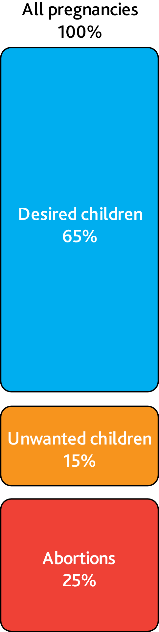
As many organizations have realized (UNFPA, Planned Parenthood, Gates Foundation etc.) contraception is also key for women’s empowerment & the reduction of poverty.

The unwanted children are often a burden to themselves, their mothers, their families, & our societies. All this takes a heavy toll on the women, whose self-determination is affected by their childbearing capacity & who are often socially excluded due to unwanted children.
Peter is an industrial designer by training & wondered what he could do to prevent these unwanted children, improve the lives of the women, & stabilize our numbers. Seeing the complications around hormone-based contraceptives, he wanted an alternative. Sterilization, once implemented after family planning is complete, is from that moment onwards the ideal form of contraception. To use it as lifetime contraception method it was required to be able to switch it on & off.
However, this cannot be achieved with sterilization methods that are currently on the market.

Peter researched if something like reversible sterilization was technically feasible. Putting together recent advances in implants, hysteroscopy, micro machines & wireless energy transfer, he created the basic idea for Choice. A patent application was filed in September 2014, around the same time that Choice B.V. was incorporated.
The valve was created in real size (1,4 mm diameter) & successfully tested against water leakage. A market focus study had been conducted at the University of Amsterdam. Young women, when questioned, felt overwhelmingly (8 out of 10) that Choice would be the ideal form of contraception for them.
Investors were sought & found in September 2018. These investors have fully financed phase I (see phases in Strategy), to prove that the Choice device is compatible with test animals. Later, more private investors stepped in with additional funding. The Brabant Startup Fonds also issued a convertible loan to Choice in June 2019. The Rabo Innovation Fund issued a soft loan in 2020.

A large coalition of technical and medical experts, universities & high-tech companies was built. A lot of special know-how was accumulated concerning implants, fallopian tubes, high-tech micro systems, regulatory aspects & markets etc. This coalition of (all internally motivated) experts are now building the whole device. A working actuator in its real tiny size was created in 2020. New designs led to new patent applications (2020 & 2021). A removable stent & a modular approach were developed, allowing the gradual addition of more benefits & the reduction of risk, both enabling a faster market introduction. We were allowed testing in animals (rabbits) in 2020. We are now testing the implants in animals (2021).

Choice is now taking the next steps to finance the rest of its development plan. This additional investment will be used for early first-in-woman testing of Choice 1.0 (see paragraph 2.1.3) & the development, testing & certification of the Choice 1.0 device & all its functional components through clinical testing. This development will in turn set the stage for the design freeze, FDA/CE testing & launch of the product. This path is outlined in more detail in the roadmap section of this business plan. We aim for investment from MedTech partners with additional expertise & to add a large MedTech partner with the access, marketing & financial abilities for the FDA/CE studies and subsequent market introduction, after first-in-woman success.

1.2 WHICH PROBLEMS DOES CHOICE SOLVE?
Choice is a new form of contraception & addresses three core medical, social & environmental issues:

- Contraception’s Side Effects – A better contraception method that is reliable, cost-effective, do not require conscious effort & do not have negative medical/hormonal side effects.
- Unwanted Children - One in 5 children born is unplanned & unwanted (UN estimate). One in 4 pregnancies is aborted. Whatever one’s position on the abortion issue, preferably there should be no demand for them – Every Child desired.
- Women’s Position in Society - Women’s ability to control their own fertility without any outside interference.
- Sustainability - Overpopulation & the quest for sustainable population growth to pro-actively deal with climate change & global resource depletion & economic development of Low-Income Countries (LIC).

1.3 CHOICE SOLUTION

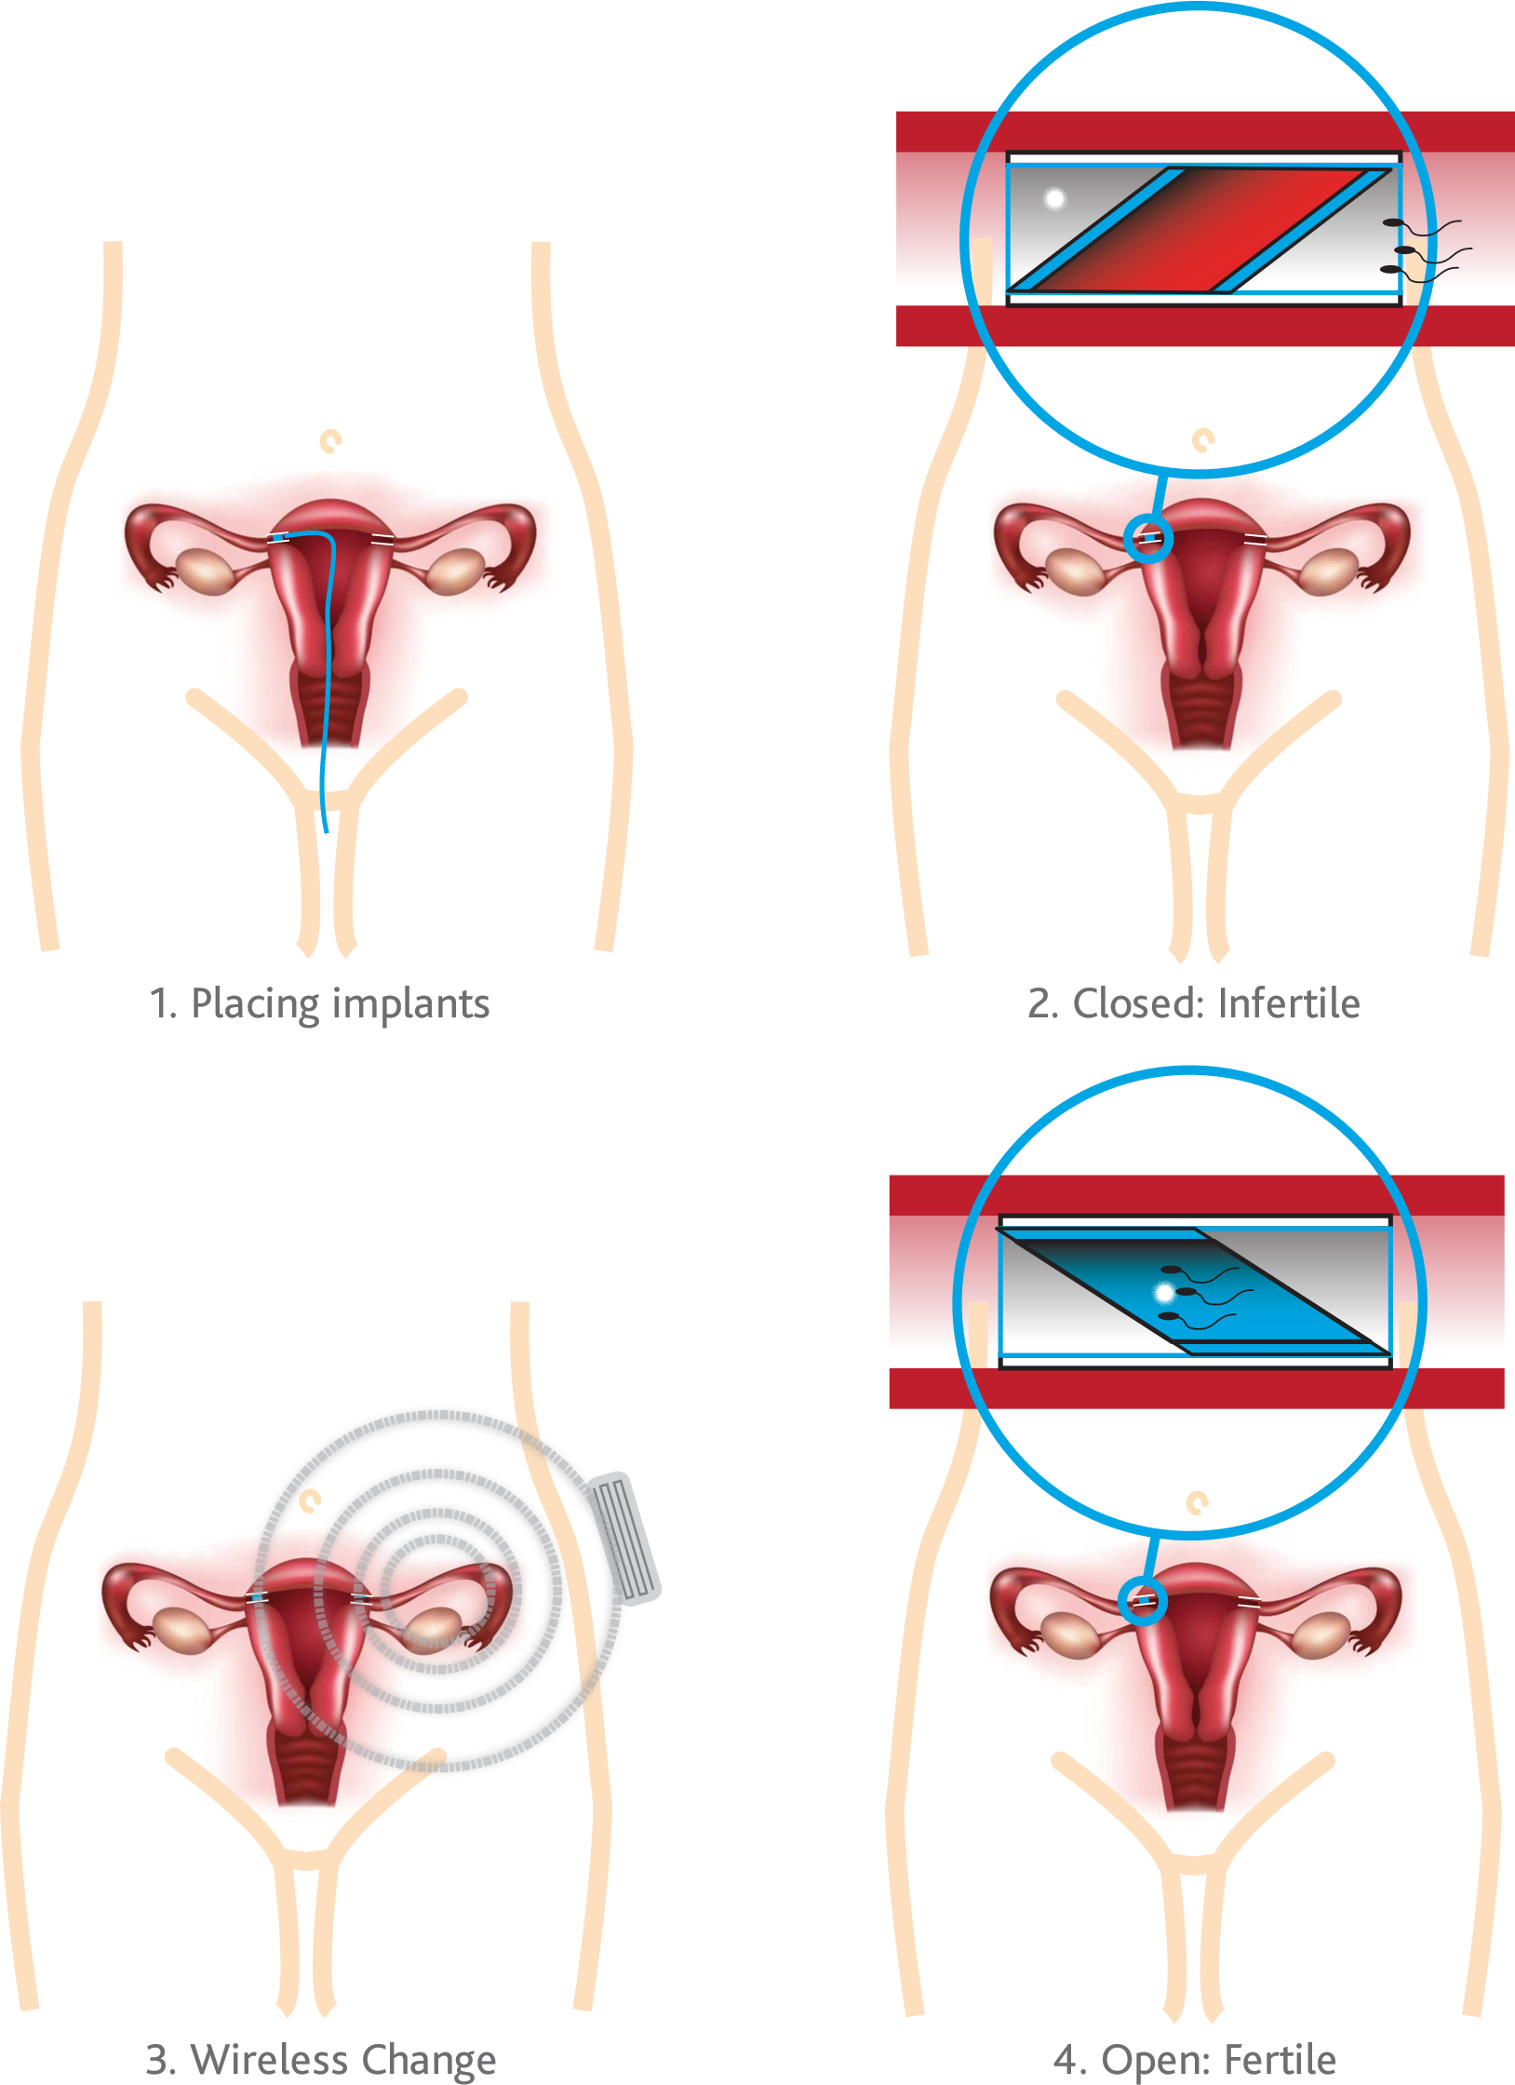

Our solution is the first where a woman opens her reproductive system only when she wants to, so that she can have babies when & only if they are most welcome. It has all the silent confidence of sterilization, while being reversible at a moment’s notice. It functions through a small & low-cost medical intervention.

Endoscopically placed valve implants in a women’s fallopian tubes, allow her to open or close her fallopian tubes from outside her body without surgical intervention, thereby giving her full control over her fertility.

It requires no hormones, no daily medication (like the pill), no recurring removal & placement like intrauterine devices (like IUD’s), nor rational behavior in a moment of passion (like condoms) & has low recurring cost for the user (only when a change in status is desired). These implants are placed only once, hysteroscopically, with minimum discomfort, & stay in women’s bodies for the rest of their lives, performing their function without fail.

Normally these valves are without energy, being open (fertile) or closed (infertile) according to the wishes of the female wearer. The valve implants can change their status (open/fertile or closed/infertile) by placing a temporary remote control with antenna on the skin of the wearer. The implants are then energized & begin to move to the opposite function. Once the opposite function is achieved the implants communicate their new status. The remote control can then be removed.

Choice mimics in essence a door in the fallopian tube, allowing conscious control over the accessibility (for gametes: sperm & egg) of the fallopian tube & the womb.

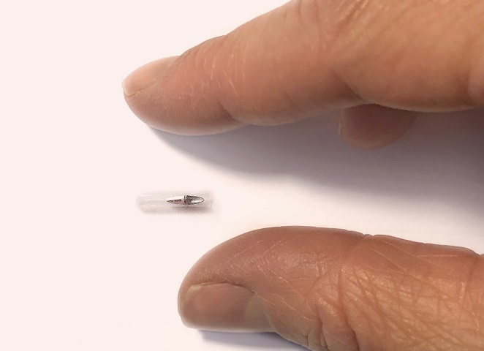

Choice model – Real size

1.4 CHOICE PRODUCT BENEFITS (UNIQE SELLING PROPOSITIONS -USPs)
Choice addresses the social, medical as well as the human aspects of contraception in comparison to existing contraceptive methods & has the following, unique benefits:

1. CAREFREE
- Hormone free, no mechanical agitation (IUD)
  - There is more & more opposition from women to hormonally and/or chemically based contraceptives. – “it is hard to say where I end & the hormones begin” (female visitor at Choice presentation).
  - IUDs like the popular Mirena have a 50% rejection rate after 3 years because of weight gain, depression, or loss of libido. IUDs through their abrasive action in the womb can also create complications. IUDs have to be regularly replaced (5-7 years).
  - Choice has no hormonal, chemical or mechanical abrasion as mechanism, it just closes the fallopian tube. Choice contains no hormones.
- Independent of user, discipline free
  - People are on average not very disciplined. One in five US women who use contraceptives do so inconsistently, accounting for 41% of unintended pregnancies of all American women.
  - Cooperation using condoms is not always given.
  - Choice does not require any discipline once implanted.
- Passion Proof
  - Sex & rational thought are incompatible bedfellows. Unwanted children often arise from passion overtaking thought.
  - Choice allows the passion, while reserving the decision for children for more levelheaded moments.
- Reversible
  - Sterilization, being a laparoscopic operation, must be considered non-reversible. But quite a few women undergo a re-fertilization procedure due to changes in their lives.
  - Choice is reversible sterilization without any surgical intervention.
- One-time placement, lifetime of use
  - Pills & condoms require recurring action. IUDs last only 5-7 years & must be exchanged or removed once a woman wants children.
  - Choice is a one-time only implant. Switching it is a simple affair in a medical post. Even if the medical post is far away, the few times family planning requires a visit, it is worth it.

- Reliability
  - Condoms are not considered comfortable, can rip, & not always there in the spur of the moment. Their reliability is much lower than other methods.
  - Using the pill during an entire fertile lifetime gives on average the chance for one (unplanned) child.
  - Choice aims for a reliability comparable to sterilization.
- Natural Feel
  - People generally dislike the interruption & feeling of using condoms while having sex, not feeling natural. While condoms are important for preventing sexually transmitted diseases, most sex happens between people in a stable union.
  - On a different level, many women feel adding hormones to their body is not natural.
  - Choice does not interfere during sex, and is mechanical in action, which women feel is much less of an influence (comparable to hip or knee implants, for instance)
2. LOW LIFETIME COST (EVENTUALLY)
- One-time placement means protection with no recurring costs (if there is no open/closed change). All other contraceptive methods (condom, pill, IUD) have recurring costs to keep the protection in place for (fertile) life. The one-time placement is of vital importance to poorer families & NGO’s: one treatment insures lifelong family planning.
- Since Choice is a medical implant (investments for FDA/CE approval significantly lower than drugs) & electronics based, it is affected by economies of scale. Estimates for the lifetime cost of Choice mass-produced implants, versus the pill, condoms, or IUD’s, show significant cost reductions. This makes it an attractive form of contraception also from an economic viewpoint, which is important for the poor as well as for insurance companies.

Life with Choice

1.5 BUSINESS MODEL 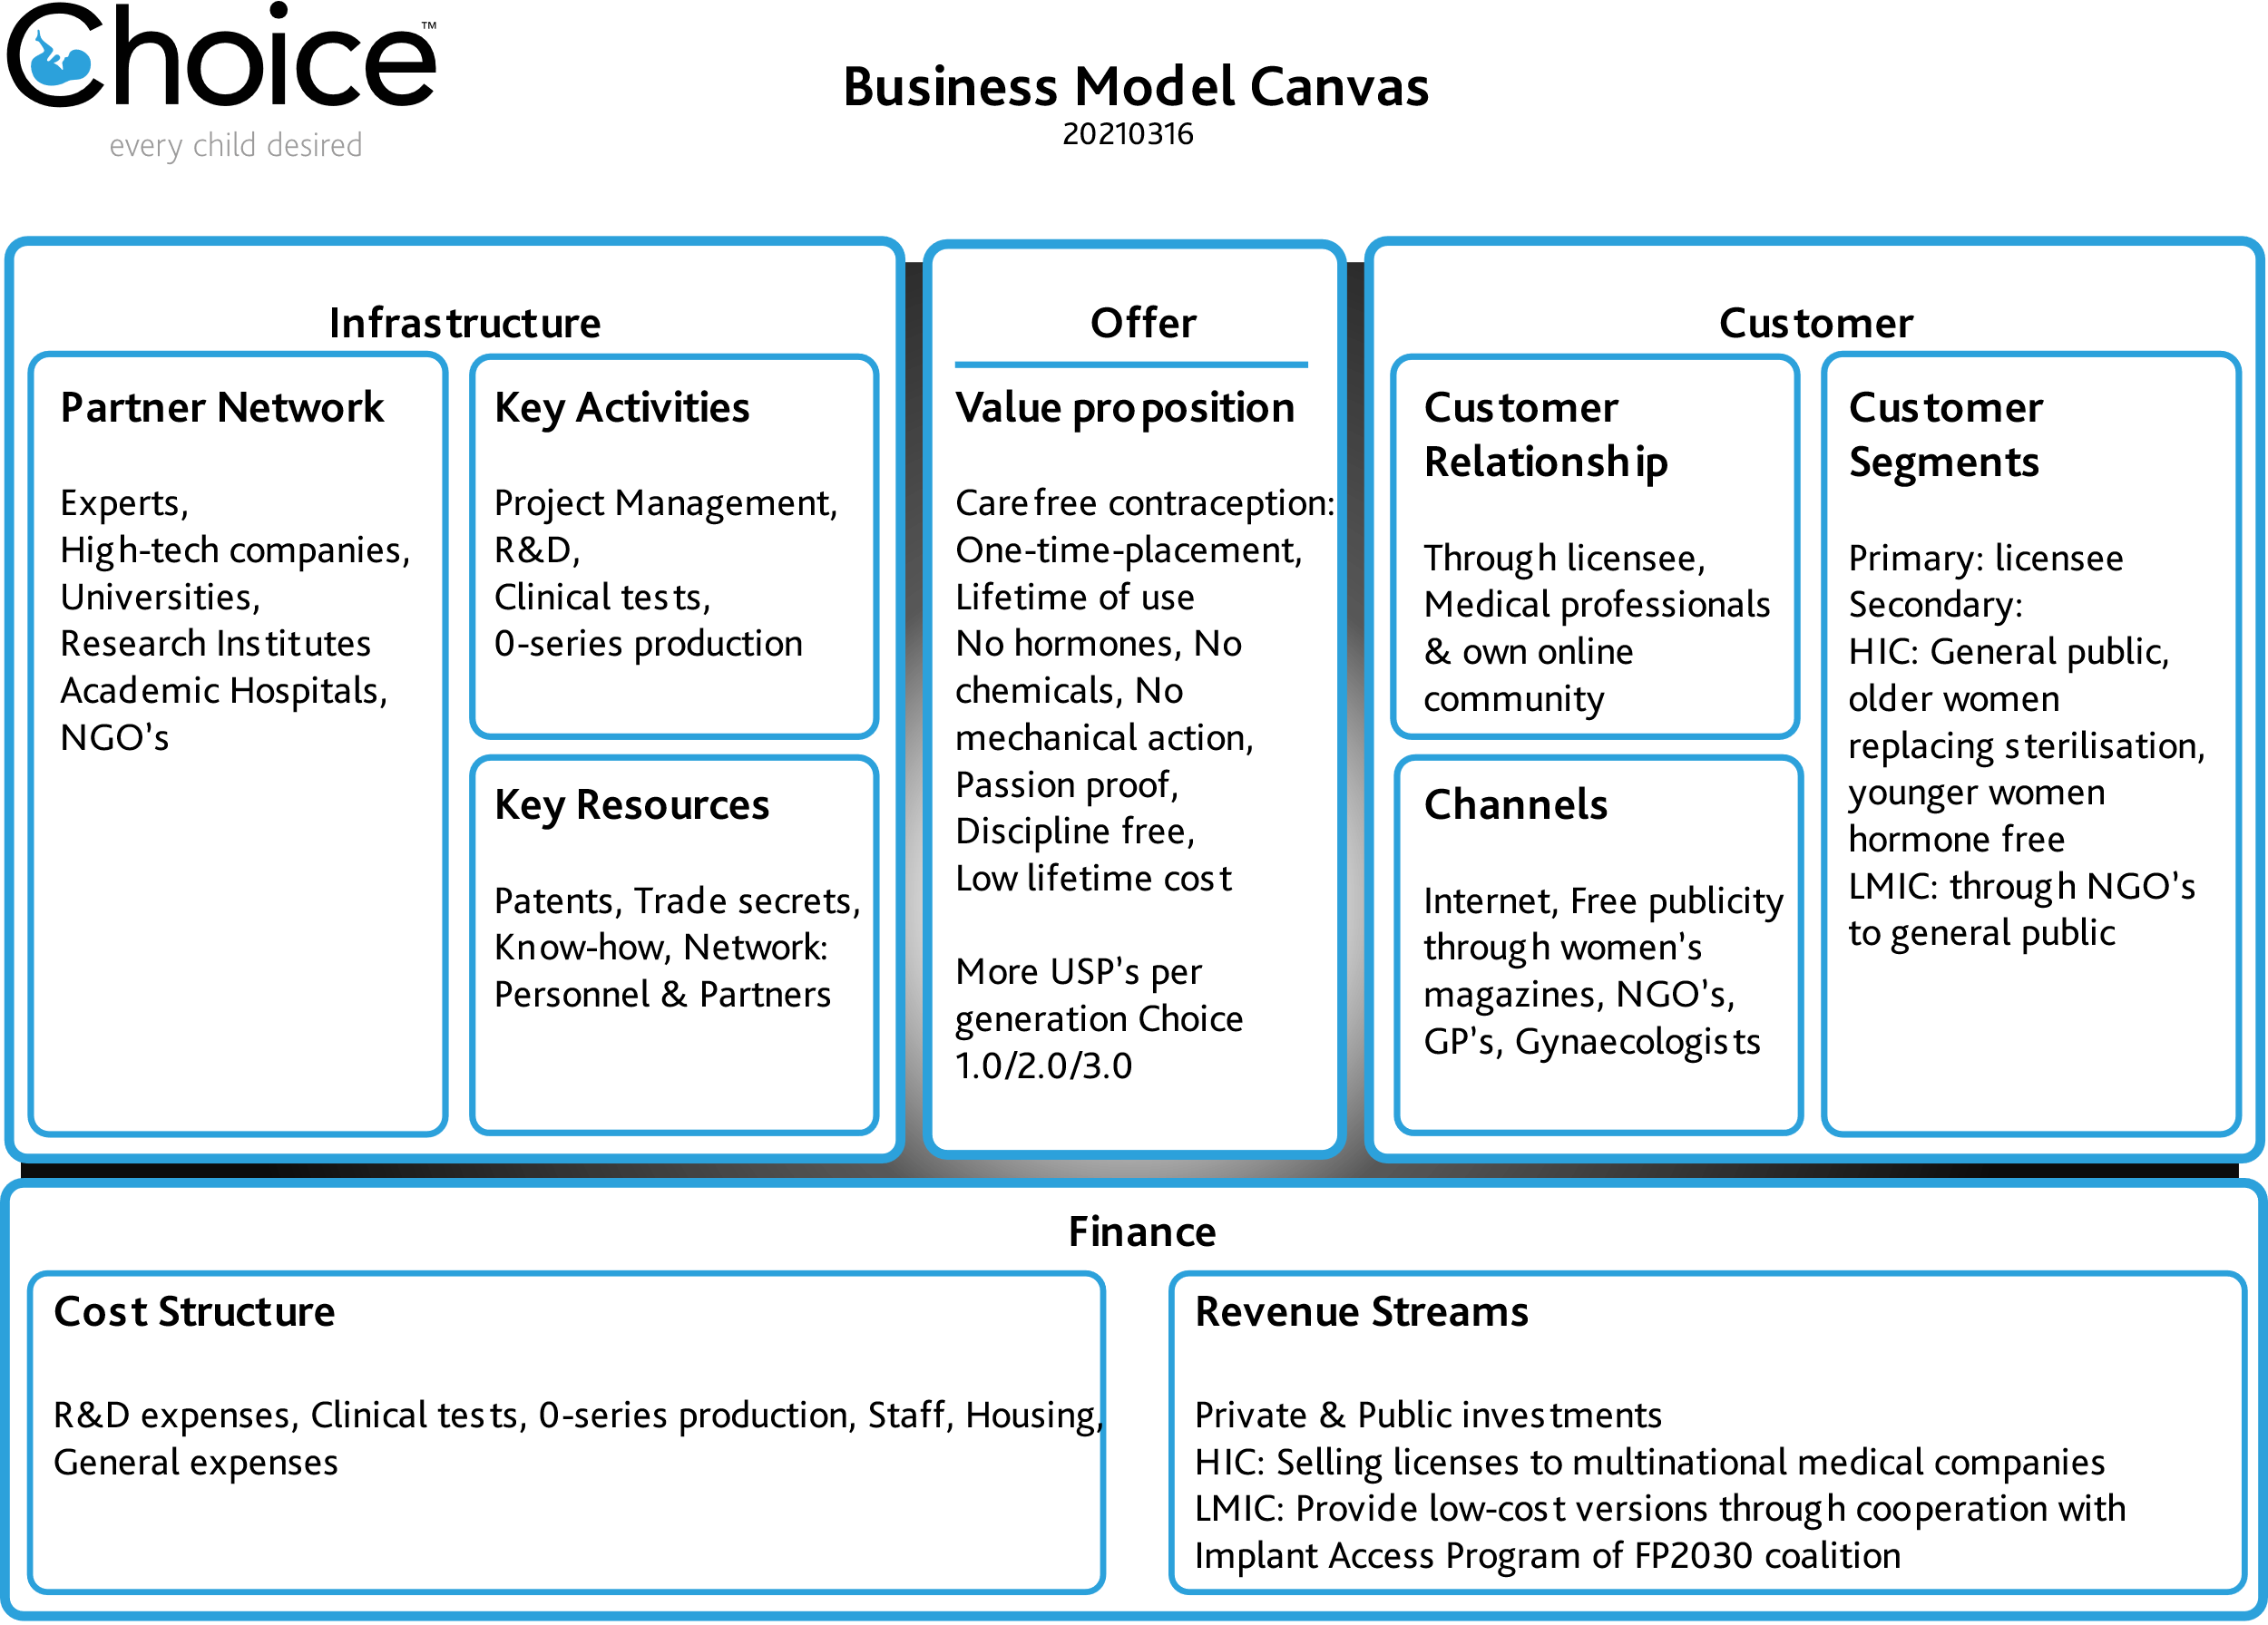

Choice is a network organization, bringing together the relevant parties (experts, high-tech companies, universities, research institutes, academic hospitals & NGO’s) to create the vision for a new contraception & create the societal embedding required for its success. The products created will be licensed out to companies with a worldwide reach, able to work with local regulatory agencies, do local marketing, distribution & training to local medical providers.

The income generated from the licenses will be used to perpetuate Choice as an R&D company, using its expanding patent & knowledge base to create more advanced versions of the original product (1.0 – 2.0 – 3.0 -….) as well as other applications (i.e., incontinence, male contraception….).

As Choice is a social enterprise) it is required to be financially successful as well as contribute to its social goals. The products will be sold in HIC (High Income Countries) on a suitable commercial basis by the licensee. For LMIC (Lower – & Middle-Income Countries) Choice will work within the framework of FP2030 (see Theory of Change, Chapter 5).

1.6 ORGANIZATION

TEAM
- Peter van de Graaf, MSc. Founder/CEO
25 years’ experience medical product design (3M Medica & his own design agency, Kiva). Dedicated his life to this essential innovation. Medical & automotive product development veteran, 7 patents to his name. Peter's major strengths are inspired concepts & the integration of all aspects relevant to the project. A seasoned designer & inventor, with international experience in a variety of industries, he can translate societal needs into solutions.
As a lecturer at the faculty of Industrial Design, Eindhoven Technical University & at Windesheim University, Industrial Product Design, he coached students, developed new health care projects, taught technology, environmental design & history & was involved in the development of a new curriculum. This was an exercise in constant innovation. He was also the project leader for a joint project with Naturalis, museum of Natural History in Leiden, in a biomimicry project to understand the workings of whale baleen.
- Jörg Stroetzel, MSc. COO
Communications engineer, with in-depth expertise in design, production, sales and marketing of telecommunications networks and products and many years of management experience at Alcatel and BKtel GmbH.
- Bert Bakker. BSc. CTO
30 years CTO & system architect experience in medical implant development.
- Leonie van de Kamer CMO
7 years’ experience in clinical study project management
- Anne Hoekstra, MSc. Research Assistant
Anne delivers data on contraception; market research & is administrative assistant.

SCIENTIFIC ADVISORY BOARD
- Prof. dr. Marlies Bongers
30 years’ experience in minimal invasive gynecologic surgery. With B. Veersema foremost Dutch specialist in tube implants, Maastricht University, MMC, Maxima Medical Center Veldhoven.
- Prof. dr. Bas Veersema
30 years’ experience in benign gynecology (see above). Utrecht University, medical scientific head of division Woman & Baby University Medical center Utrecht.
- Prof. dr. ir. Peter Baltus
35 years’ experience in wireless systems & IC design. Chair of the Mixed-Signal Microelectronics group in the Department of Electrical Engineering at Eindhoven University of Technology (TU/e).

SPECIAL ADVISOR
- Dr. Joris Bannenberg
35 years’ experience Medical Device Regulatory & Clinical Consultant

2. Products & Strategy

2.1 GOAL
The goal of Choice is to become the license provider for the most widely used contraceptive method in the world. This chapter looks at the current contraceptive market and the relationship of Choice to that market. It concludes with a strategy to reach the described goal.

2.2 CURRENT MARKET
The following contraceptive methods are in use worldwide: (year: 2019, Modern & Traditional):

 | 2019 | Contraception
 | in million people | basis
Female sterilization | 219 | Nonreversible surgery
Pill | 151 | Hormone
Injectable | 74 | Hormone
Implant | 23 | Hormone
IUD | 159 | Hormone or Chemicals
Male condom | 189 | Condom
Male sterilization | 16 | Nonreversible surgery
Rhythm | 29 | Body temperature, etc.
Withdrawal | 47 | Coitus interruptus
Other | 15 | others
Total | 922

On top of this, the UN & the Gates Foundation estimate that 220 million women in LIMC have an unmet need for & no access to contraception.

Direct competition for Choice comes from hospitals, that provide sterilization procedures, & big pharmaceutical companies providing contraceptives. Excluding sterilization, as a procedure more than a product, about half of the users apply contraceptive hormonal drugs (pill etc.), one quarter uses IUDs & one quarter uses condoms. Hormonal IUDs (Bayer’s Mirena) are a mix of both.
The market for existing contraceptives is highly fragmented, with the pharmaceutical giants Pfizer, Bayer & Merck being the most significant players & potential direct competitors.

VALUE
The global contraceptives market was valued at $ 24202.12 million in 2018 & is estimated to generate net revenue of approximately $44010.44 million by 2027, growing at a CAGR of 6.96%. (Inkwood Research).
The largest part (2016) of this is contraceptive drugs (mostly the pill) at $ 6500 million followed by intrauterine devices (IUD’s) $ 3800 million & male condoms, also $ 3800 million. Other methods are male & female sterilizations, implantables, cervical caps etc., making up the remainder of the market.

COMPETITIVE ANALYSIS
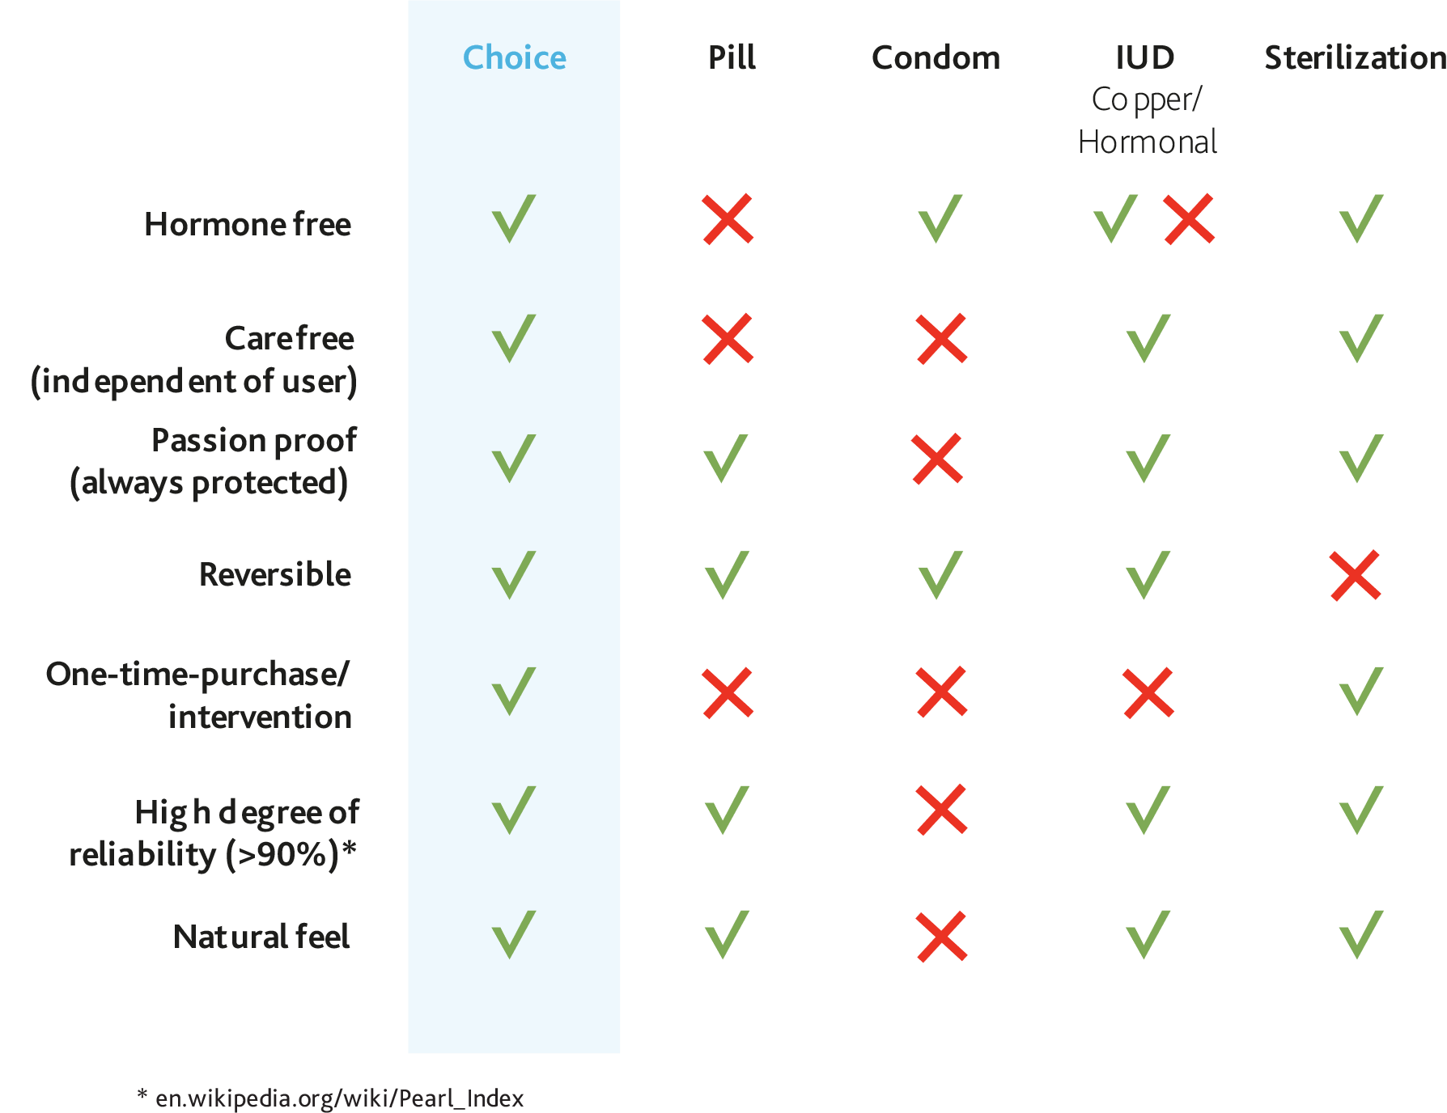

Calculating a replacement market for each of these contraceptive methods, we eventually expect:

- Sterilization. The market share of women who are sterilized can be expected to be 50%, since the Choice system eliminates the need for surgery. Furthermore, Choice has the great advantage of being a reversible sterilization.
- Pill/Hormone based contraception. From various research we know that about 33% to 50% of women are dissatisfied with hormonal contraception, due to the influence of hormones on women's body & mind.
- IUD’s. We expect the IUD market to achieve a share of 75%. IUD's need to be renewed regularly, contain chemicals or hormones & are painful to insert into the cervix.
- Condoms. In the condom market, we expect 5%, as Choice does not protect against sexually transmitted diseases.
New products under development are:
- the Dare vaginal ring, which can be inserted for a month & is chemical based.
- Microchips, supported by the Gates foundation, an implantable chip releasing hormone.
Both have the same disadvantages as the pill & the IUD’s, as they work with chemicals & hormones.

UNMET NEED
This is where Choice wants to have its greatest societal impact, by aligning with the FP2030 program. See for more details Chapter 3 Theory of Change

Market share in figures:

 | 2019 | Potential | Market share
 | in million | in % | in figures
Female sterilization | 219 | 50% | 109.5
Pill | 151 | 33% | 49.8
Injectable | 74 | 33% | 24.4
Implant | 23 | 33% | 7.6
IUD | 159 | 75% | 119.3
Male condom | 189 | 5% | 9.5
Other | 107 | ? | ?
Total | 922 |  | 320.0 | (in million women)

CONCLUSION
This means that with a Total Addressable Market (TAM) of 922 million women, a Serviceable Addressable Market (SAM) of 320 million women can be assumed.

VALUE
Please contact Peter van de Graaf for more information:
pvandegraaf@choiceforwomen.org or +31 65 325 0 325

2.3 STRATEGY
Please contact Peter van de Graaf for more information:
pvandegraaf@choiceforwomen.org or +31 65 325 0 325

2.4 INTELLECTUAL PROPERTY
Please contact Peter van de Graaf for more information:
pvandegraaf@choiceforwomen.org or +31 65 325 0 325

2.5 OTHER OPPORTUNITIES
Please contact Peter van de Graaf for more information:
pvandegraaf@choiceforwomen.org or +31 65 325 0 325
3. Theory of Change

3.1 PROBLEM
Although there are already many types of contraceptives on the market, women still experience unwanted or unplanned pregnancies. About half of all pregnancies that take place worldwide are unintentional (3, 13). The consequences of an unintended pregnancy are major. First, more than 340,000 women die every year from maternal causes. Without contraceptives, mortality would be about 1-8 times higher. If all women who need contraception could actually use it, this figure would decrease 29 percent, about 104,000 maternal deaths per year (1).

In many developing countries, unintended pregnancy has far-reaching consequences for the physical & psychological health of women & their families & contributes to poverty, malnutrition, lack of sanitation & education (8). An unintended pregnancy also has undesirable consequences outside developing countries. Although little research has been done, unintentional pregnancy appears to be a risk factor for the mental health of the mother herself (2,6,9,11). In addition, an unintended pregnancy is also a risk factor for the health of the child. An indirect consequence is that, because of the higher health risks, there are also higher healthcare costs for society (7,10). In the longer term, there are also consequences for the child: for example, they run increased risks in terms of psychosocial development & mental well-being as adults. Children born after an unintended pregnancy are less likely to excel academically, experience job satisfaction and have more difficulties in parenting (5).

Many unintended pregnancies end in abortions. It is estimated that approximately 61 percent of all unintended pregnancies worldwide end in abortion (3). In countries where abortion is illegal & unsafe, unintended pregnancies are a major contributor to morbidity & mortality in women (13). An estimated 68,000 women die each year from unsafe abortions (16). In countries where abortion is legal & safe, opting for an abortion is drastic & emotionally taxing (12).

Good contraception therefore helps women to participate fully in society, without worrying about the consequences of an unwanted pregnancy.

3.2 ACTIVITIES
With Choice we have decided to focus on contraception for women because they often suffer the consequences of an unwanted pregnancy.
Our product will offer women a choice for a safe, reliable, hormone-free & Long-Acting Reversible Contraceptive (LARC), so that they can take control of their fertility without affecting the rest of their body. LARCs are well suited for Low- & Middle-Income Countries (LMICs) (15), because they can be distributed through mobile outreach, with relatively few contact moments. They are also the most effective reversible methods of contraception because their efficiency is not reliant on patient compliance and are the most cost-effective in the long term (14).
With Choice we want to reach all women on earth to make unwanted pregnancies a thing of the past. We strive to make sure that every child on earth is desired, so that the children who are born have the best possible start in life.

3.2.1 Current activities
Choice is currently developing a LARC product (see chapter 1.1) that must be implanted once & then remains effective for a lifetime. Current LARCs require intermittent care in the space of months (implants) or several years (IUDs). Choice (3.0) only needs a visit for a non-invasive antenna contact when the family planning requires a change in status. On the one hand, this increases the ease of use & comfort for the individual user, on the other hand, Choice is therefore suitable for use in areas where healthcare is less accessible.

Choice seeks to have this product widely available to women at all economic levels throughout the world. We are currently endorsed & working together with several NGOs, such as the Rutgers Foundation & the Population Council, & we make use of their very relevant expertise.

3.2.2 Investment strategy
Impact
Choice's starting point is to contribute to a better world. We strive to improve the lives of women worldwide through better birth control. In this way, Choice contributes to achieving the Sustainable Development Goals of the United Nations. The work of choice mainly contributes to the achievement of goal 3: Ensure healthy lives & promote well-being for all at all ages. But also, more indirectly helps to achieve the following goals: 1. No poverty, 2. Zero hunger, 5. Gender equality, 10. Reduced inequalities, 13. Climate action.

How?
To make Choice available to all women in the world, we want to make Choice available at a heavily discounted price in low-middle income countries. We want to achieve this by participating in initiatives such as the Implant Access Program (IAP) within the global framework of FP2030. The IAP model, as already followed by other industry players (i.e. Bayer, Merck, Pfizer & others), is that Choice organizes ultimate low cost manufacturing of the device, in exchange for guaranteed demand from development organizations such as UNFPA & USAID. This demand is made possible by international sponsors. Choice strives for parity, for every commercial Implant in High Income Countries (HICs) a low-cost implant is distributed in LMICs.

3.3 IMPACT OBJECTIVES
3.3.1. Give women in LMIC’s access to contraception
In the 5 years after the market introduction, Choice aims to give 15M women in low-middle income countries access to long-acting reversible contraception. These women previously had no access to modern contraceptives. By providing these women with contraception, they gain control over their health, fertility & thus over their lives. As a consequence, these women & their families will have a better standard of living, their society will benefit & their ecological footprint will be diminished.

Our low-cost production capacity for low-middle income countries must therefore equal our production facility for high income countries in output.

3.3.2 Prevent unwanted pregnancies
In the 5 years after the market introduction, Choice aims to prevent nearly 1M unwanted pregnancies. In developing regions, the unintended pregnancy rate is 65 per 1000 women in a period of five years (4). If 15M women got access to Choice, this would prevent almost 1M (975.000) unwanted pregnancies five years after implantation of Choice.

3.4 REFERENCES
1. Ahmed, S., Li, Q., Liu, L., & Tsui, A. (2012). Maternal deaths averted by contraceptive use: an analysis of 172 countries. The Lancet, 380(9837), 111-125.
2. Barton, K., Redshaw, M, Quigley, M., & Carson, C. (2017). Unplanned pregnancy and subsequent psychological distress in partnered women: a cross-sectional study of the role of relationship quality and wider social support. BMC Pregnancy and Childbirth, 17(44), 1-9.
3. Bearak, J., Popinchalk, A., Moller, A., Tunçalp, O., Beavin, C., Kwok, L., & Alkema, L. (2020). Unintended pregnancy and abortion by income, region, and the legal status of abortion: estimates from a comprehensive model for 1990-2019. The Lancet 8(9), e1152-e1161.
4. Bearak, J., Popinchalk, A., Alkema, L., & Sedgh, G. (2018). Global, regional, and subregional trends in unintended pregnancy and its outcomes from 1990 to 2014: estimates from a Bayesian hierarchical model. The Lancet 6(4), e380-e389.
5. David, H. (2006). Born Unwanted, 35 Years Later: The Prague Study. Reproductive Health Matters, 14(27), 181-190.
6. Herd, P., Higgins, J., Sicinski, K., & Merkurieva, I. (2016). The Implications of Unintended Pregnancies for Mental Health in Later Life. Perspectives From the Social Sciences, 106(3), 421-429.
7. Joyce, T.J., Kaestner, R., Korenman, S. (2000). The effect of pregnancy intention on child development. Demography, 37(1), 83-94.
8. Klima, C.S. (1998). Unintended pregnancy. Consequences and solutions for a worldwide problem. J Nurse Midwifery, 43(6), 481-491.
9. Maxson, P., & Miranda, M.L. (2011). Pregnancy Intention, Demographic Differences, and Psychosocial Health. Journal of Women’s Health, 20(8), 1215-1223.
10. Mosher, W.D., Jones, J., & Abma, J.C. (2012). Intended and Unintended Birth in the United States: 1982-2010. National Health Statistics Reports, 55, 1-27.
11. Orr, S., & Miller, C. (1997). Unintended pregnancy and the psychosocial well-being of pregnant women. Women’s Health Issues, January-February 1997, 38-46.
12. Rutgers (2020, October 2). Anticonceptie en abortus – Regie over kinderwens. Retrieved from https://rutgers.nl/wat-wij-doen/anticonceptie-en-abortus-regie-over-kinderwens.
13. Santelli, J., Rochat, R., Hatfield-Timajchy, K., Colley Gilbert, B., Curtis, K., Cabral, R., Hirsch, J., & Schieve, L. (2003). The Measurement and Meaning of Unintended Pregnancy. Perspectives on Sexual and Reproductive Health, 35, 94-101.
14. Stoddard, A., McNicholas, C., & Peipert, J. (2011). Efficacy and safety of long-acting reversible contraception. Drugs 28(71), 969-980.
15. USAID (2019). Approaches for Expanding Choice and Access to Long-Acting Reversible Contraceptives and Permanent Methods of Family Planning. Retrieved from https://www.usaid.gov/sites/default/files/documents/1864/LARCPM_FactSheet.pdf.
16. World Health Organization (2005). The World Health Report 2005. Make every mother and child count. Geneva: World Health Organization.
- Projected Financial Figures
Please contact Peter van de Graaf for more information:
pvandegraaf@choiceforwomen.org or +31 65 325 0 325

5. Risk Analysis

Please contact Peter van de Graaf for more information:
pvandegraaf@choiceforwomen.org or +31 65 325 0 325

Conclusion

We are convinced Choice is the contraception women all over the world want & that we are in a position to make it a reality. We have brought together the necessary know-how in a broad team, containing leading experts, companies & institutions on technical, medical, clinical, financial and management aspects. We have shown technical feasibility & are demonstrating biocompatibility. The demand will be vast, women want this yesterday, this will be good for us all. We invite you to become part of our story.

Peter van de Graaf , Msc.
pvandegraaf@choiceforwomen.org
Tel: +(31) 65 325 0325

