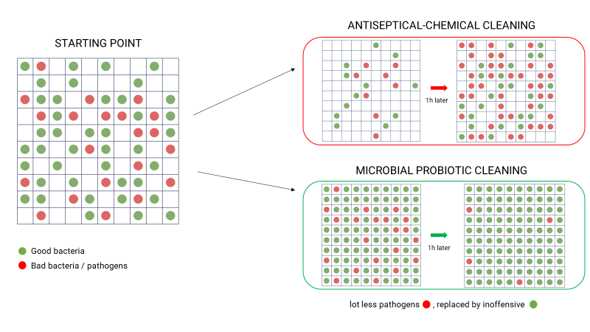 EXECUTIVE SUMMARY
Probiotic Group develops and produces its own probiotic strain cultures for external applications in cleaning, care and environmental sanitation. It solves challenges such as oversilking (misuse of antiseptics), antimicrobial & antibiotic resistance and dysbiosis that greatly increase the mortality rates.

The estimated market will reach around 9bio€ at the end of 2018 with a growth rate of 10+% a year.

KEY SUCCESS FACTORS OF THE COMPANY
- Intense R&D program supported by strong academic partners technological leadership
Own Gen0 product on the market scientifically proven by external entities such as private labs
- 98% client satisfaction rate proved by testimonials, ratings and reordering
- Agile program management thanks to its current size
- Protects against infection risks, does cure skin illnesses as well as antimicrobial resistance

DEVELOPMENT PRIORITIES – USE OF THE FUNDS
- Finalization of the R&D program in collaboration with the LIST and LCSB. IP remains in PBG.
- Strengthening the marketing and sales efforts

LOOKING FOR
2.950.000 EUR in order to raise an additional 5,25Mi EUR
> Break-even foreseen in 2 years
> Funding leverage thanks to a public-private partnership and banks support

TERM SHEET SUMMARY
- 15 % of the capital open
Gen0 kills 99% of
E.coli and Staphylococcus bacteria in less than 24 hours
- Multiple exit strategies including sale to a current market leader
- Ideal timeline: closing in November 2019

ELEMENTS TO REMEMBER
- Market currently in the “technology trigger” phase
- Specific products positioning with less, if none, regulatory hurdles
- Early commercial traction on multiple markets including lead with Kazidomi, McDonalds, Tom&Co and orders through Amazon. Around 25 leads currently in discussions/negotiations
- Present in 100+ stores and active in countries such as Belgium, The Netherlands, France, Germany and United Kingdom
- Very attractive margin by an integration of the vertical value chain from production to commercialization

